# Writing and Reading Files

## Writing to files in Python.

Open your python editor, save the new file as **Write_and_Read.py** in your documents folder. and type in the following code:

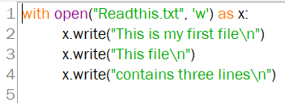

1. Run the code. What is displayed on your screen?

|  |
| --- |
| Nothing is displayed |

1. What do you think happened when you executed the code?

|  |
| --- |
| It writes the three lines to a text file called Readthis.txt (creates the file if needed) |

1. Using **File Explorer**, go to your documents folder. You should see a new text file in your there. What is the name of the text file?

|  |
| --- |
| Readthis.txt |

4. Open the file and copy and paste the data that is inside the text file here (ignore the indentation).

|  |
| --- |
| This is my first file  This file  contains three lines |

Type the following code into the **Write_and_Read.py** file that you have open.

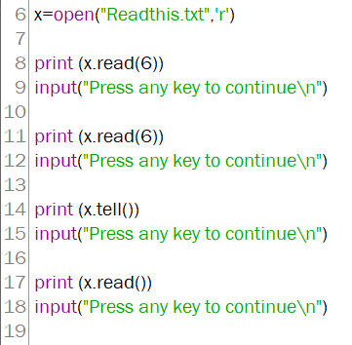

5. What appears in your output when line 8 is executed? What does the data represent?

|  |
| --- |
| This I (this the first 6 characters) |

6. What appears in your output when line 11 is executed? What does the data represent?

|  |
| --- |
| s my f (this is the next 6 character) |

7. What appears in your output when line 14 is executed? What does the data represent?

|  |
| --- |
| 12 (this is your current postition) |

8. What appears in your output when line 17 is executed? What does the data represent?

|  |
| --- |
| irst file  This file  contains three lines (this is everything after postiton 12) |

9. What are three ways to read an entire 3 line text file? Explain briefly how each works.

|  |  |
| --- | --- |
| Ways to read a 3 line text file | Explanation |
| for line in X:      print(line, end = "\n") | Loops through the file printing each line and skiping a space until all the files lines are printed |
| X.read() | Prints the whole file |
| X.readline()  X.readline()  X.readline() | Prints each line one by one (only works with a three line file ) |